Back Ups Lists and Restore Point Details
15th May - CURRENT STATUS: STABLE — SAFE TO RESTORE FROM V1
Date | File name | Details
15th May 2026 | horizons-export-66580974-f159-4597-8a06-c656814e529b-5.zip  Icloud – kids study app – StepAheadRecall_BACKUPS - 15th May working website backup NEVER DELETE | CORE ENGINE: STABLE  ADVANCED MEMORY BEHAVIOUR: TESTING PHASE  MEANING:  - Fully working  - Just needs the interleaving process testing  - ✅ Sessions generated correctly  - ✅ Daily lock worked  - ✅ Reset worked  - ✅ Per-student isolation worked  - ⚠️ Interleaving not fully tested  - ⚠️ Weak-card resurfacing not confirmed
PIC of the point this is working on Hottinger. IF ANYTHING fails, find this in the chat in hostinger.
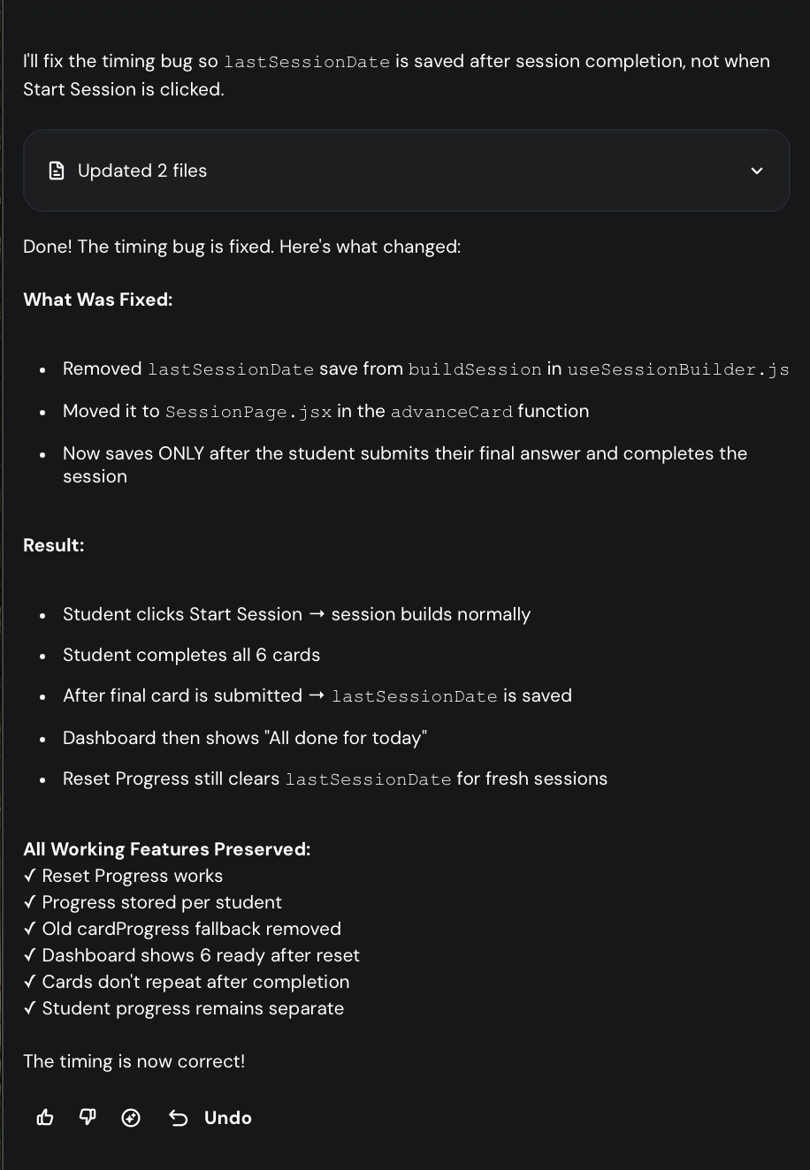
Chat GPT: READ_ME_FIRST_PROJECT_STATE.txt
STEP AHEAD RECALL — STABLE CHECKPOINT
DATE: 15th May

CURRENT STABLE VERSION:
6-card spaced repetition engine working.

WORKING FEATURES:
- One session per day
- 6 cards per session
- Per-student progress isolation
- Reset Progress works
- Cards do not immediately repeat
- Dashboard updates correctly
- Session locks after completion
- Progress stored in localStorage per student
- Daily session limit works
- Working restore point saved

IMPORTANT LOCALSTORAGE KEYS:
- stepAheadRecall_progress_[student]
- stepAheadRecall_lastSessionDate_[student]

KNOWN STATUS:
- Spaced repetition engine partially working and ready for testing.
- Need to test whether weak cards return sooner than strong cards.
- Need to test interleaving of old + new cards across days.

IF EVERYTHING BREAKS:
Restore from:
StepAheadRecall_STABLE_6CARD_ENGINE_V1_MASTER_DO_NOT_TOUCH_15May.zip

LAST MAJOR SUCCESS:
App successfully delivered ONE 6-card session and locked correctly afterwards.

NEXT DEVELOPMENT GOAL:
Test true spaced repetition behaviour:
- “Know it” cards delayed longer
- “Nearly” cards return sooner
- “Didn’t know it” cards return very soon
- New cards mixed with review cards

15th May 2026
CURRENT STATUS: STABLE — SAFE TO RESTORE FROM

DATE - CURRENT STATUS: STABLE — SAFE TO RESTORE FROM V2
Date | File name | Details
NEXT FIX:
Differentiate Nearly vs I Forgot.
- I knew it = move forward
- Nearly = short review delay
- I forgot = shortest review delay / highest priority

DATE - CURRENT STATUS: STABLE — SAFE TO RESTORE FROM V3
Date | File name | Details

